**ToDo webapp**

pip install --upgrade django-crispy-forms

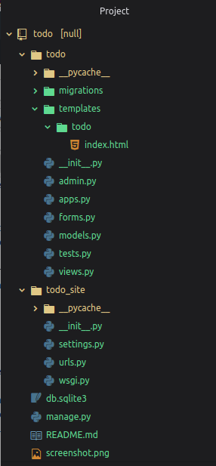

Setting.py

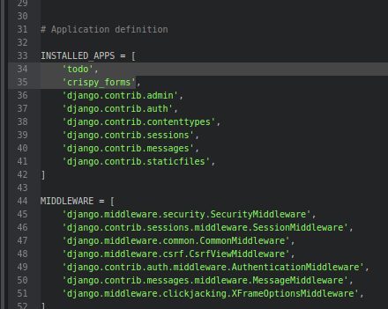

**urls.py file in todo_site**

from django.contrib import admin

from django.urls import path

from todo import views

urlpatterns = [

#####################home_page###########################################

path('', views.index, name="todo"),

####################give id no. item_id name or item_id=i.id ############

# pass item_id as primary key to remove that the todo with given id

path('del/<str:item_id>', views.remove, name="del"),

########################################################################

path('admin/', admin.site.urls),

]

**models.py**

**from django.db import models**

**from django.utils import timezone**

**class Todo(models.Model):**

**title=models.CharField(max_length=100)**

**details=models.TextField()**

**date=models.DateTimeField(default=timezone.now)**

**def __str__(self):**

**return self.title**

**view.py**

**from django.shortcuts import render, redirect**

**from django.contrib import messages**

**## import todo form and models**

**from .forms import TodoForm**

**from .models import Todo**

**###############################################**

**def index(request):**

**item_list = Todo.objects.order_by("-date")**

**if request.method == "POST":**

**form = TodoForm(request.POST)**

**if form.is_valid():**

**form.save()**

**return redirect('todo')**

**form = TodoForm()**

**page = {**

**"forms" : form,**

**"list" : item_list,**

**"title" : "TODO LIST",**

**}**

**return render(request, 'todo/index.html', page)**

**### function to remove item, it receive todo item_id as primary key from url ##**

**def remove(request, item_id):**

**item = Todo.objects.get(id=item_id)**

**item.delete()**

**messages.info(request, "item removed !!!")**

**return redirect('todo')**

**forms.py**

**from django import forms**

**from .models import Todo**

**class TodoForm(forms.ModelForm):**

**class Meta:**

**model = Todo**

**fields="__all__"**

**index.html**

|  |
| --- |
| {% load crispy_forms_tags %} |
|  | <!DOCTYPE html> |
|  | <html lang="en" dir="ltr"> |
|  |  |
|  | <head> |
|  |  |
|  | <meta charset="utf-8"> |
|  | <title>{{title}}</title> |
|  | <meta name="viewport" content="width=device-width, initial-scale=1"> |
|  | <link rel="stylesheet" href="https://maxcdn.bootstrapcdn.com/bootstrap/3.3.7/css/bootstrap.min.css"> |
|  | <script src="https://ajax.googleapis.com/ajax/libs/jquery/3.3.1/jquery.min.js"></script> |
|  | <script src="https://maxcdn.bootstrapcdn.com/bootstrap/3.3.7/js/bootstrap.min.js"></script> |
|  | <!--style--> |
|  | <style> |
|  | .card { |
|  |  |
|  | box-shadow: 0 4px 8px 0 rgba(0,0,0,0.5), |
|  | 0 6px 20px 0 rgba(0,0,0,0.39); |
|  | background: lightpink; |
|  | margin-bottom : 5%; |
|  | border-radius: 25px; |
|  | padding : 2%; |
|  | overflow: auto; |
|  | resize: both; |
|  | text-overflow: ellipsis; |
|  | } |
|  | .card:hover{ |
|  | background: lightblue; |
|  | } |
|  |  |
|  | .submit_form{ |
|  |  |
|  | text-align: center; |
|  | padding: 3%; |
|  | background: pink; |
|  | border-radius: 25px; |
|  | box-shadow: 0 4px 8px 0 rgba(0,0,0,0.4), |
|  | 0 6px 20px 0 rgba(0,0,0,0.36); |
|  | } |
|  | </style> |
|  |  |
|  | </head> |
|  |  |
|  | <body class="container-fluid"> |
|  |  |
|  | {% if messages %} |
|  | {% for message in messages %} |
|  | <div class="alert alert-info"> |
|  | <strong>{{message}}</strong> |
|  | </div> |
|  | {% endfor %} |
|  | {% endif %} |
|  |  |
|  | <center class="row"> |
|  | <h1><i>__TODO LIST__</i></h1> |
|  | <hr /> |
|  | </center> |
|  |  |
|  | <div class="row"> |
|  |  |
|  | <div class="col-md-8"> |
|  |  |
|  | {% for i in list %} |
|  | <div class="card"> |
|  | <center><b>{{i.title}}</b></center> |
|  | <hr/> |
|  | {{i.date}} |
|  | <hr/> |
|  | {{i.details}} |
|  | <br /> |
|  | <br /> |
|  | <form action="/del/{{i.id}}" method="POST" style=" padding-right: 4%; padding-bottom: 3%;"> |
|  | {% csrf_token %} |
|  | <button value="remove" type="submit" class="btn btn-primary" style="float: right;"><span class="glyphicon glyphicon-trash"></span> &nbsp; remove</button> |
|  | </form> |
|  | </div> |
|  | {% endfor%} |
|  | </div> |
|  | <div class="col-md-1"> </div> |
|  | <div class="col-md-3" > |
|  | <div class="submit_form"> |
|  | <form method="POST"> |
|  | {% csrf_token %} |
|  | {{forms|crispy}} |
|  | <center> |
|  | <input type="submit" class="btn btn-default" value="submit" /> |
|  | </center> |
|  | </form> |
|  | </div> |
|  | </div> |
|  | </div> |
|  | </body> |
|  |  |
|  | </html> |

**Output**